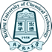
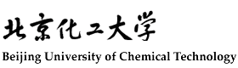
北京化工大学2023年来华留学生研究生项目招生简章

北京化工大学创办于1958年，是新中国为“培养尖端科学发展所需的高级化工技术人才”而创建的一所高水平大学。作为教育部直属的全国重点大学、国家“211工程”和“‘985’优势学科创新平台”重点建设院校，国家“双一流”大学，北京化工大学肩负着高层次创新人才培养和基础性、前瞻性科学研究以及原创性高新技术开发的使命。
学校由三部分组成，东校区位于北京北三环东路，交通便利；西校区坐落于北京紫竹院公园西侧，环境优雅；北校区在北京市昌平区内，近邻著名的十三陵风景区。
北京化工大学经过60余年的建设，已经发展成为理科基础坚实，工科实力雄厚，管理学、经济学、法学、文学、教育学、哲学、医学等学科富有特色的多科性重点大学，形成了从本科生教育到硕士研究生、博士研究生、博士后流动站以及留学生教育等多层次人才培养格局。目前，学校共设有17个院系，在校全日制本科生约15300人，研究生约8100人（其中博士约1100人），函授、夜大等继续教育学生约2700人，留学生约460人。
学校师资队伍实力雄厚。大力实施“人才强校”战略，现有教职工2600余人，其中两院院士14人，教育部“长江学者奖励计划”特聘教授12人，青年学者5人，国家杰出青年基金获得者24人，国家优秀青年科学基金获奖者30人，“973”首席科学家8人次，国家“万人计划”科技创新领军人才10人，“百千万人才工程”国家级人选8人，“中国青年科技奖”获得者8人，“首都科技领军人才”获得者5人，“北京市级高等学校教学名师奖”获得者31人，教育部跨（新）世纪优秀人才65人。
学校国际交流合作日益广泛。坚持“全球化发展”战略，着力健全国际交流合作体制机制，不断优化全球合作网络体系，重点推进“一带一路”建设。学校与美、英、法、俄、德、澳、韩、日、意等48个国家（地区）的165所大学和机构建立合作伙伴关系。建有3个北京市国际合作联合实验室（研究中心）和3个北京市国际科技合作基地；坚持以“高精尖缺”人才引进为重点，20项引智项目获得科技部国家级“高端外国专家引进计划”立项；在校长期任职的外籍专家共18人；积极推进学生国际化交流，与19个国家（地区）的60余所高校和机构开展80余项学生赴海外学习项目。继续推进“北化-世界百强高校本硕博精英计划”，30名优秀学生由国家留学基金委等资助赴境外进行攻读博士学位或博士联合培养。杜邦公司、陶氏公司、巴斯夫公司、拜尔公司、罗纳普朗克公司等 10 余家公司向在校学生提供奖学金。学校可招收从语言生到本科生，硕士生以及博士生的多层次化的留学生。

一、招收专业及学制
硕士学位：学制3年 （普通进修生：1－2年）注：加※为英文授课专业
化学工程学院 | - 化学工程与技术※ | 经济管理学院 | 15.管理科学与工程
 | - 环境科学与工程 |  | 16.会计学
材料科学与工程学院 | - 材料科学与工程※ |  | 17.企业管理※
 |  |  | 18.技术经济及管理
机电工程学院 | - 工程力学 | 化学学院 | 19.化学※
 | - 机械工程
 | 6.动力工程和工程热物理 | 数理学院 | 20.物理学
 | 7.安全科学与工程 |  | 21.数学
信息科学与技术学院 | 8.控制科学与工程 | 生命科学与技术学院 | 22.轻工业技术与工程
 | 9.信息与通信工程 |  | 23.药学
 | 10.软件工程 |  | 24.生物工程※
 | 11.新一代电子信息技术 | 文法学院 | 25.法学
 | 12.计算机技术 |  | 26.公共管理
 | 13.控制工程 | 马克思主义学院 | 27.马克思主义理论
 | 14.计算机科学与技术※
博士学位：学制4年 （高级进修生：1年）英文授课
化学工程学院 | 1.化学工程与技术 | 信息科学与技术学院 | 5.控制科学与工程
 | 2.环境科学与工程 | 机电工程学院 | 6.动力工程与工程热物理
材料科学与工程学院 | 3.材料科学与工程 | 生命科学与技术学院 | 7.生物工程
化学学院 | 4.化学 | 经济管理学院 | 8.管理科学与工程

- 申请及录取流程

1. 申请登录北京化工大学报名系统进行网上报名，填写报名表并上传申请材料。http://study.buct.edu.cn；
2. 资料初审；
3. 视频面试；
4. 通知最终录取结果；
5. 学校寄送《JW201/202表》及《录取通知书》。
注：面试通知以及录取结果将通过注册邮箱通知。

- 申报材料
- 个人简历；
- 最高学历毕业证明以及成绩单（需公证）；
- 两封副教授以上推荐信；
- 研究学习计划；
- 个人照片、个人护照；
- 外国人体检表；
- 导师接收函；
- 无犯罪记录证明；
- 英语或HSK水平证书；
- 学术出版物、专利和其他学术成果的原件或扫描件（如有则优先考虑）。
注：
1.申请者需在网上申请前获得北京化工大学导师接收函并上传到申请网站，若无导师接收函，则申请者则不能获得面试机会。
申请者可通过以下网址获得导师详细信息：
https://en-sie.buct.edu.cn/2612/list.htm
2.申请者进行线上申请并上传以上所有资料，资料不全者直接淘汰，不必邮寄纸质版申请资料。

四、学习费用
- 报名费、注册费：500元（只在申请入学时交一次）
- 学费：
1) 博士研究生：35000元/年
2) 硕士研究生（中文授课)：30000元/年
3）硕士研究生（英文授课)：35000元/年
- 住宿费： 东校区60元/床/天
昌平校区70元/间/天
- 保险费：800元/年

五、奖学金
1. 中国政府奖学金
- 奖学金内容： 免除学费和校内住宿费；
发放生活费-硕士3000元/月，博士3500元/月；
免除综合医疗保险费用800元/人/年；
- 申请方式：
- 通过中国驻国使领馆或教育部申请-Type A
使领馆接受申请的时间一般是每年11月至次年4月，请注意提前问询查询。
2）通过北京化工大学申请-Type B
登录国家留学基金委网站https://studyinchina.csc.edu.cn (北京化工大学机构代码 10010)；北京化工大学申请网站http://study.buct.edu.cn 两个网站进行线上报名。截止日期为2023年4月15日，滚动录取。
注：其中中国政府奖学金-高校研究生项目专门为优秀人才设定，报名截止日期2022年12月23日。

- 校长奖学金
北京化工大学校长奖奖学金项目只招收博士研究生。奖学金内容以及申报流程与中国政府奖学金项目相同。申请截止时间为2023年4月15日。

- 北京市政府奖学金
北京政府奖学金提供给申请北京化工大学的优秀外国留学生。该项奖学金减免半年/一年学费。学生在线申请后，由学校根据成绩等申请材料组织考试或者考核评审。详见北京市政府奖学金招生简章。 申请截止日期为2023年6月20日。
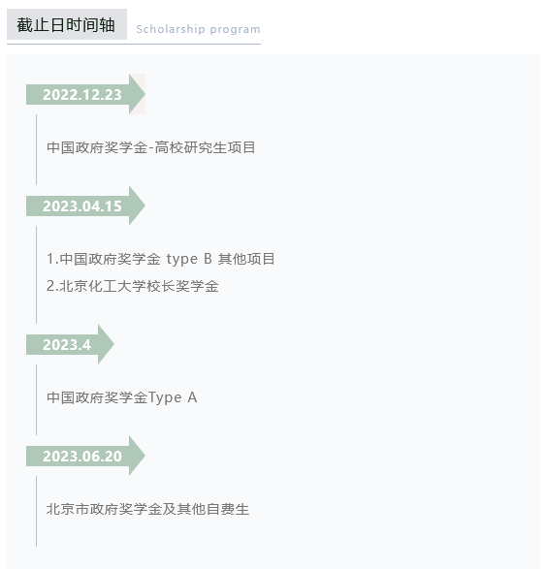
六、联系方式
学校地址：中国北京北三环东路15号北京化工大学国际教育学院留学生办公室
邮政编码：100029
联系人： 吴老师 赵老师 电话：0086-10-64452461
Email: buctapply@mail.buct.edu.cn 官方网址： http://www.buct.edu.cn
Facebook：https://www.facebook.com/groups/buctapplication
Beijing University of Chemical Technology
2023 Admission for Postgraduate Program

Founded in 1958 and formerly known as Beijing Institute of Chemical Technology, Beijing University of Chemical Technology (BUCT) is a national key university directly affiliated to Ministry of Education of China, one of the Project 211 universities and 985 Project Innovation Platforms. BUCT shoulders the mission of innovative talent education, scientific research, and high-tech development.
After 60 years of continuous efforts, BUCT has developed into a multi-disciplinary institute with a solid foundation in science and engineering, along with other distinctive disciplines such as Business Management, Economics, Law, Literature, Philosophy, Education, Medical Science and etc. It has formed a complete talent development system from the undergraduate level, the postgraduate level up to the postdoctoral level. In the ESI rankings, chemistry and material science have entered the top 1‰, the disciplines of material science, engineering, biology and biochemistry top 1%. The primary discipline of Chemical Engineering and Technology ranked the third in China. The BUCT “Green Chemistry, Chemical Engineering and Materials” discipline group was listed as a First-Class Discipline in the Double First-Class Project in 2017.
BUCT, with a global vision, has successively established academic collaboration with 165 universities from Asia, Europe, America, Africa, Oceania. BUCT is now running more than 86 study-abroad programs. BUCT also offers a wide range of education programs for international students including bachelor’s, master’s and doctoral programs as well as Chinese language and culture programs, exchange programs and summer camps and etc.
In the 21st century, which is full of opportunities and challenges, BUCT will continue to hold fast the university motto “to be ambitious, virtuous, profoundly learned, to explore the mysteries of nature, strive for better services for human beings” and try its best to develop BUCT into a world class research institution with distinctive characteristics and international influence.

History
1958-Beijing Institute of Chemical Technology(BICT) was founded, affiliated to the Ministry of Chemical Industry.
1994-Name changed to Beijing University of Chemical Technology.
1996-Became one of the first Universities to be in the Project 211(Top 211)
1998-Affiliated to the Ministry of Education
2008-Became one of the 985 Project Innovation Platforms for Priority.
2017-”Green Chemistry, Chemical Engineering and Materials” was listed as First-Class Discipline in Double First -Class Project.

Key Facts on BUCT
One of Project 211 universities
One of the 985 Project Innovation Platforms
Multi-disciplinary-It is a multi-disciplinary university with science and engineering retained as the core disciplines with the addition of arts, the science of law, management and economics.
First-Class Discipline in the Double First-Class Project in“Green Chemistry,Chemical Engineering and Materials”
17 Colleges/Schools
2,600+ Faculty members and staff
15,000+ Undergraduate students
7,500+ Postgraduate students
600+ International students
500+ /year Study -abroad Students
2 State Key Laboratories
30+ Provincial Joint Laboratories/Centers
5+ International joint Laboratories/Research Centers
160+ Overseas Cooperation Partners

Postgraduate Programs
Master’s Program (3 years) (※: curriculum taught in English)

College of Chemical Engineering | 1.Chemical Engineering and Technology※ | College of Economics and Management | 15.Management Science and Engineering
 | 2.Environmental Science and Engineering |  | 16.Accounting
College of Material Science and Engineering | 3.Material Science and Engineering※ |  | 17.Business Administration ※
 |  |  | 18.Technical Economy and Management.
College of Mechanical and Electrical Engineering | 4.Engineering Mechanics | College of Chemistry | 19.Chemistry※
 | 5.Mechanical Engineering
 | 6.Power Engineering and Engineering Thermophysics | College of Science | 20.Physics
 | 7.Safety Science and Engineering |  | 21.Mathematics
College of Information Science and Technology | 8.Controlling Science and Engineering | College of Life Science and Technology | 22.Light Industry Technology and Engineering
 | 9.Information and Communication Engineering |  | 23.Pharmacy
 | 10.Software Engineering |  | 24.Biological Engineering ※
 | 11.New Generation Electronic Information Technology | College of Humanities and Law | 25.Law
 | 12.Computer Technology |  | 26.Public Administration
 | 13.Control Engineering | College of Marxism | 27.Marxism Theory
 | 14.Computer Science and Technology※
Doctor’s Program (4 years)
College of Chemical Engineering | 1.Chemical Engineering and Technology | College of Information Science and Technology | 5.Controlling Science and Engineering
 | 2.Environmental Engineering | College of Mechanical and Electrical Engineering | 6.Power Engineering and Engineering Thermophysics
College of Materials Science and Engineering | 3.Materials Science and Engineering | College of Life Science and Technology | 7.Biological Engineering
College of Chemistry | 4.Chemistry | College of Economics and Management | 8.Management Science and Engineering

- Application and Admission Process
- Register your account and activate in http://study.buct.edu.cn，fill out your Application online and upload the materials;
- Document review;
- Online interview;
- Admission announcement (All accepted applicants will be informed via Email.);
- Receive the admission Letter and JW201/JW202 form by DHL.

Admission Materials
- CV;
- Two letters of reference from professor or associate professor;
- Study and research plan;
- Original Transcript and Diploma of the highest Degree(notarized);
- Passport size photos, passport copy;
- Photocopy of Foreigner Physical Examination Form;
- Acceptance letter from one supervisor;
- No Criminal Record Certificate;
- English or HSK proficiency certificates ;
- Originals or copies of academic publication, patent, and other academic achievements (If any, priority will be given).
Note：
- Applicants requires a preliminary acceptance letter from a BUCT professor and upload it online. Or else you will not be considered as a candidate.
Participating Professors information can be found at the
https://en-sie.buct.edu.cn/2612/list.htm
- Applicants are required to upload all materials as above, Or else you will not be considered as candidate. It is not mandatory to send copies of application materials to BUCT.

- Scholarships
- Chinese Government Scholarship (CSC Scholarship)
- What does the scholarship cover?
Tuition and accommodation;
Living expenses:Master RMB 3000 yuan / month,Dr RMB 3500 yuan / month;
Comprehensive medical insurance: RMB 800 yuan / person /year;
- How to apply?
There are two ways to apply for CSC Scholarship:
- Apply through the Chinese Embassy/Consulate or Ministry of Education in your country (Recommended method of application)-Type A
Note: CSC applications typically begin in January every year but for more specific application dates please contact the respective institutions(Embassy or Ministry)
- Apply through BUCT -Type B
Applicants must to submit the application to both following website:
BUCT online application system http://study.buct.edu.cn and CSC application system https://studyinchina.csc.edu.cn (BUCT Agency No. is 10010). The application deadline is April 15,2023 (rolling admission).
Note: The Chinese Government Scholarship-University Graduate Program is set for the best talents, and the application deadline is December 23,2022.

- Beijing University of Chemical Technology Presidential Scholarship
The Beijing University of Chemical Technology Presidential Scholarship program only enrolls doctoral students. The scholarship content and application process are the same as the Chinese Government Scholarship program. The application deadline is April 15,2023.

- Beijing Government Scholarship
- What does the scholarship cover?
1 year/half year tuition fee (review every year)
- How to apply?
Register account and activate in http://study.buct.edu.cn, fill out your application online, School of International Education will organize the assessment according to application materials.The application deadline is June 20,2023.
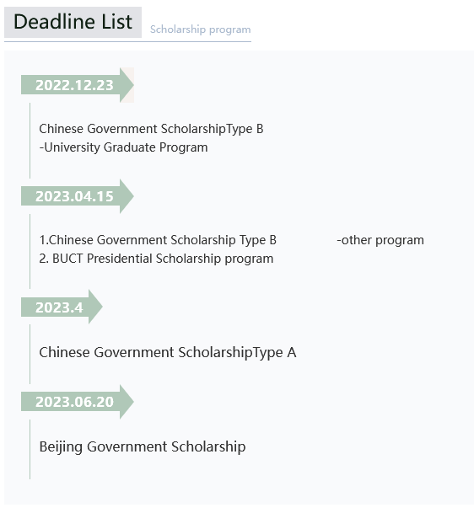
- Financial matters
Application fee: RMB 500 (only once)
Insurance Fee: RMB 800 /year
Tuition fees:
Doctoral Students: RMB 35000/year
Master Students(Chinese Instructed) : RMB 30000/year
Master Students (English Instructed): RMB 35000/year
Accommodation:
RMB 60 / bed / day in the east campus
RMB 70 /room /day in the north campus

- Contact
Ms.Wu
International Students Office
School of International Education
Beijing University of Chemical Technology
No. 15 Bei San Huan East Road, Chaoyang District, Beijing, 100029
Phone:0086-10-64452461
Email:buctapply@mail.buct.edu.cn
Website: http://www.buct.edu.cn English version
Facebook：https://www.facebook.com/groups/buctapplication

