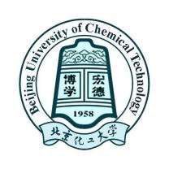

Student’s NAME
Student’s organization,
City, Nationality

Dear FULL NAME,

I am very pleased to provide this letter as an acceptance letter for you to come to Beijing University of Chemical Technology (BUCT) as a Master/PhD student for 3 /4 years, starting on September 1, 2022 and ending July 15, 20XX, in my research center in College of XXXXXXX. I believe that your English/Chinese has met the requirement to study in the Master or PhD program (major in Chemical Technology and Engineering,or XXX ).

After your registration, I would like to have you to conduct research in the area of XXXX. My research center is very well equipped. I hope that your background of student’s highest degree will be a significant contribution to my research team.

Please feel free to contact me if you have any questions about my acceptance letter. I look forward to your joining my research group at BUCT.

Sincerely,

Prof’s NAME.
Professor
College of xxxxxxx
Email:
Phone:

